The frequency band from 300 GHz to 3.0 THz ( = 10⁻³ m to 10⁻⁴ m) is rich in potential applications, but there is a lack of efficient sources within this “THz gap.” Consequently, the terahertz band has been termed “the last electromagnetic frontier.” This gap in sources arises from the sharp decrease in the efficiency and power output of solid-state electronic amplifiers at frequencies above 100 GHz along with the unavailability of compact, uncooled optical sources for wavelengths longer than the infrared. Vacuum electronic devices are a promising solution over solid-state technologies owing to fundamental advantages of truly ballistic transport within the “empty-state”. Future THz systems hold great promise for leveraging the unique properties of THz waves, which are long enough in wavelength to be penetrating through clothing and skin, but are short enough to be useful for imaging, are resonant with complex molecular bonds, and are low enough in energy to be safe and non-ionizing.

As vacuum electronic devices scale up in frequency their dimensions must be scaled down in size, eventually pushing the limits of precision machining, and necessitating the use of microfabrication techniques. However, successful vacuum electronics devices have been fabricated using traditional machining, including a BWO capable of producing 1 mW at 1 THz and a 670-GHz extended interaction klystron (EIK) able to produce 100 mW. The care with which these devices must be assembled and mechanically aligned prevents them from being practical in any applications requiring high volume or high levels of device and system integration.

We have proposed a micro-fabricated Barkhausen-Kurz (μ-BK) oscillator as a promising candidate THz source. The Barkhausen-Kurz is a general electronic oscillator concept developed nearly a century ago. The μ-BK oscillator has significant advantages over other vacuum electronic devices, promising high DC-to-THz efficiency and low startup current requirements. This device achieves high efficiency by extracting energy over multiple passes of favorably phased electrons confined within a potential well.

The need for an emitter integrated into a parabolic potential well poses a major fabrication challenge. The basic fabrication process for the cavity and integrated poly-silicon carbide thermionic cathode has been demonstrated, providing the foundation for developing stable cathodes for injecting a sheet electron beam and for optimizing the electrode geometry for defining a parabolic potential well. Batch fabricating the entire tube in a single substrate would not only dramatically reduce assembly and alignment complexity, but it would enable a new paradigm of highly integrated “THz systems on a chip”.

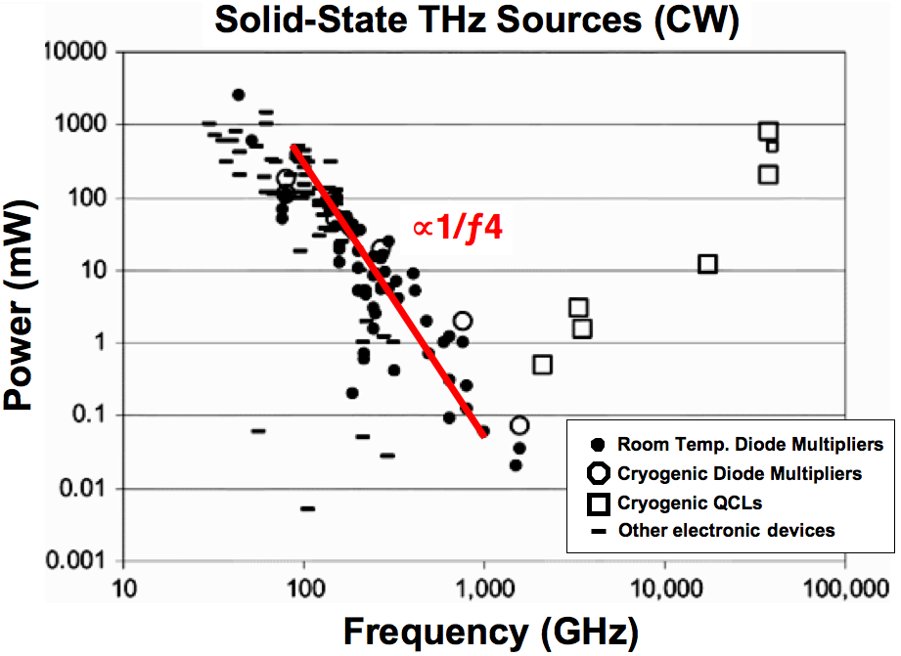
The “THz Gap”.

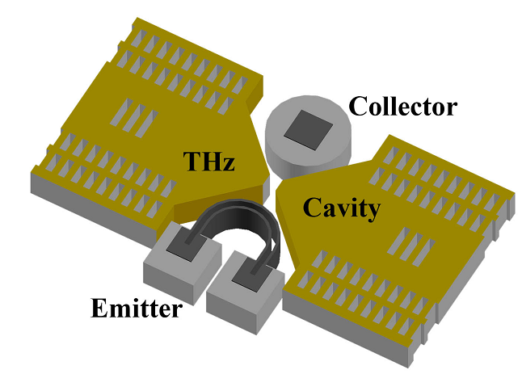
3D view of the μ-BK showing quadrupole electrodes surrounding the vacuum interaction region. The emitter, collector, and THz resonant cavity form the four quadrupole electrodes.

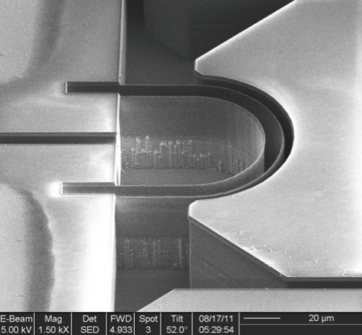
SEM showing a lateral sidewall emitter with integrated collector after fabrication is completed. The transfer of scallops and vertical striations formed during the silicon DRIE into the conformally deposited poly-SiC film are clearly visible.

Publications

“Micro Barkhausen-Kurz Oscillators for Terahertz Integrated Systems”, A. Dixit, J.P. Snapp, and T.H. Lee, 2014 International Vacuum Electronics Conference (IVEC), Monterey, CA, USA (April 22-24, 2014)

“Sidewall Silicon Carbide Emitters for Terahertz Vacuum Electronics”, J.P. Snapp, J.-H. Lee, J. Provine, I. Bargatin, R. Maboudian, T.H. Lee, and R.T. Howe, 2012 Solid-State Sensor and Actuator Workshop, Hilton Head Island, SC, USA (June 3-7, 2012)

“The Return of the Empty State: Vacuum Nanoelectronics for Terahertz Applications” (invited), T.H. Lee, J.P. Snapp, R.T. Howe, International Test Conference, Austin, TX, USA (November 4, 2010)

“Ballistic Vacuum Electronics for THz Systems on a Chip” (invited), J.P. Snapp, R.T. Howe, T.H. Lee, SURA Terahertz Applications Symposium, Washington, DC, USA (June 4, 2008)

“Terahertz Systems on a Chip: Technology and Applications”, J.P. Snapp, R.T. Howe, T.H. Lee, SURA Terahertz Applications Symposium, Washington, DC, USA (June 6, 2006)

